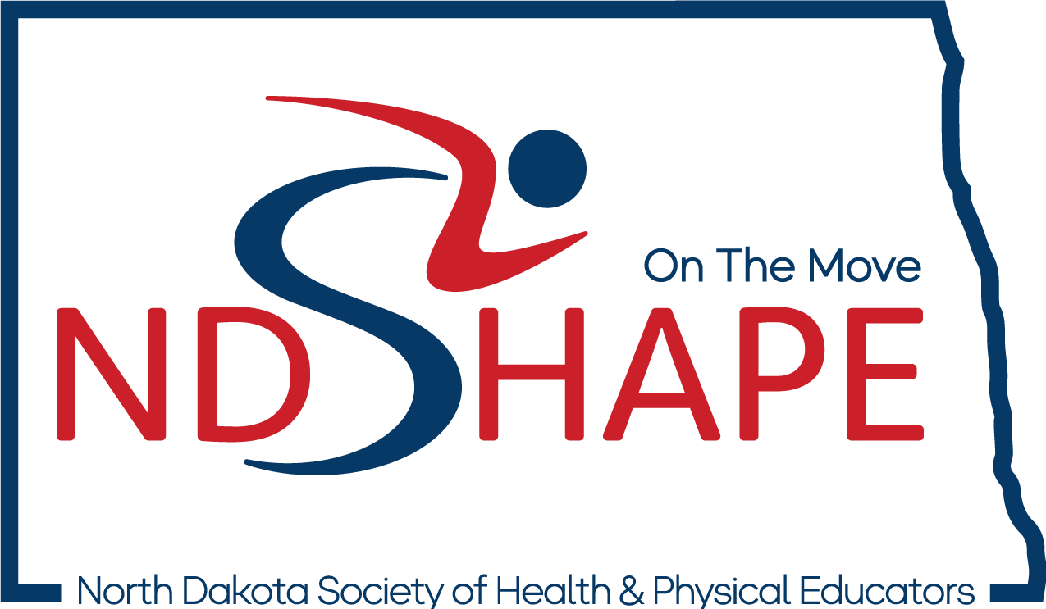
FUTURE PROFESSIONALS WORKSHOP

University of Jamestown
Newman Arena
April 3rd, 2024

Please share your day with us:
@NDSHAPE #NDSHAPEfpshop

2024 ND SHAPE Future Professional Workshop
Presentations
9:15 - 9:20 am
Welcome - Chris Mahoney, U. of Jamestown, Workshop Host
9:20 - 9:40 am
Health. Moves. Minds. - Dr. Joe Deutsch, NDSU, SHAPE America President-Elect

9:45 – 10:30 am
The Amazing Race: Fitness through the Team Challenge [Arena] Sheila Peterson, Wachter M.S., Bismarck, ND
Description: This is a session about how to use the Amazing Race Challenge to encourage teamwork, fitness, and creativity. The Amazing Race requires students to complete a series of challenges to obtain all the clues to win the race. This session is derived from Kate Cox SWD TOY 2018.

10:40 – 11:25 am
Explicit SEL Instruction in PE [Arena] Leah Wheeling, Simle M.S., Bismarck, ND
Description: Students will participate in multiple stations that explicitly teach specific SEL concepts and reflection on lessons learned throughout the activities.
Yoga Activities in Secondary PE [Lobby] Whitney Spah, Bismarck H.S., Bismarck, ND

Description: Participants will gain ideas on how to integrate mind and body exercises in Secondary PE classes. Resources will be provided for yoga training as well as credible videos to use in class. Towards the end of the session participants will participate in a short yoga session.
Athlete-Centered Coaching [Booster Room] Dr. Brandon Foye, NDSU, Fargo, ND
Description: By encouraging athletes to take greater personal responsibility and to take ownership over their results, some have argued that athlete-centered coaching leads to more consistent and high performing athletes. This session will provide an introduction to an athlete-centered approach and provide some basic steps toward becoming an athlete-centered coach.

11:35 – 12:20 pm
Weird Things I Took from Twitter [Arena] Sheila Peterson, Wachter M.S., Bismarck, ND
Description: It is easy to get our athletes to love to move....but how do I get all kids to love to play and be active. The answer: weird games that engage their problem-solving skills, activities that are weird and students couldn't have practiced, things that make them belly laugh together. Attendees will learn a variety of quick hitter activities that are easy to play with small or large groups.
Embedding Social & Emotional Learning in Sport Units [Lobby] Dr. Kelsey Higginson, Minot State, Minot, ND

Description: There are many great specific games and activities that teach social and emotional skills, but many PE teachers teach sport units most of the time. Can you still teach social and emotional skills while also learning ultimate frisbee or soccer? Yes! Come learn how to deliberately embed social and emotional skills into sport lessons.

A Smorgasbord of Health Lessons [Booster Room] Kristen Hahne, Simle M.S., Bismarck, ND
Description: This session will walk you through many health lessons including refusal skills, goal setting and advocacy. Walk away with access to lessons/materials/instructions.

12:20 – 1:00 pm LUNCH [Newman Concourse]

1:00 – 1:30 pm
Sport Stacking and your Brain [Arena] Amy Heuer, ND SHAPE, Bismarck, ND
Description: Physical education classes are not just for your physical health. We, as PE educators, can also have a huge impact on our students' brain development and academic achievement. During this session, you will learn the benefits of sport stacking to bilateral coordination, right and left-brain activation, eye-hand coordination, while learning the basics of stacking and putting those skills to the test.

1:40 – 2:25 pm
Fitness for All [Arena] Whitney Spah, Bismarck H.S., Bismarck, ND
Description: Participants will gain ideas on how to incorporate fitness activities in a High School Setting AND make it fun. We will focus on more choice and student-led participation in the classroom. Some activities were created by my students! Participants will leave with activities that can be used as a warm-up, workout or cool down, or all three!
Resources & Planning for the Health Classroom [Lobby] Kristen Hahne, Simle M.S., Bismarck, ND
Description: New to teaching health? This session will share tips, tricks, resources and planning for the health classroom.
Online Ideas - How do I know if they are good? [Booster Room] Dr. Ruth Chen, Minot State, Minot, ND Description: The Health Activities in the Classroom covers 7 of the 8 National Health Education Standards while providing an opportunity to experience a hands-on or interactive approach primarily at the secondary level.

2:35 – 3:20 pm
Combined/Large Classes!?! No Problem [Arena] Leah Wheeling, Simle M.S., Bismarck, ND Description: Due to sub shortage many PE teachers are often left covering double PE classes of 50-70 students. Participants will partake in 8 different large group activities that maximize student participation!

3:20 pm Workshop Closing & Door Prizes* [Arena]
*Must be present to win

2024 ND SHAPE Future Professionals Workshop
Wednesday, April 3rd ~ University of Jamestown ~ Newman Arena

Schedule
8:45-9:15 am Check-In – Newman Arena Lobby
9:15 am Welcome – Arena
Health. Moves. Minds. - Dr. Joe Deutsch, NDSU, SHAPE America President-Elect
Arena Lobby Booster Room
9:45 - The Amazing Race:
10:30 am Fitness through Team
Challenge
Sheila Peterson
Wachter Middle School

10:40 - Explicit SEL Instruction Yoga Activities in Athlete-Centered
11:25 am in Physical Education Secondary PE Coaching
Leah Wheeling Whitney Spah Dr. Brandon Foye
Simle Middle School Bismarck High School NDSU

11:35 am - Weird Things I took Embedding Social & A Smorgasbord of
12:20 pm from Twitter: How to get Emotional Learning Health Lessons
kids asking “What are in Sport Units Kristen Hahne
we doing today?” Dr. Kelsey Higginson Simle Middle School
Sheila Peterson Minot State
Wachter Middle School

12:20 -1:00 LUNCH [Newman Concourse]

1:00 – Sport Stacking & your Brain 1:30 pm Amy Heuer
ND SHAPE Co-Executive Director

1:40 - Fitness for All Resources & Planning Online Ideas: How do
2:25 pm Whitney Spah for the Health Classroom I know if they are any good? Bismarck High School Kristen Hahne Dr. Ruth Chen
Simle Middle School Minot State

2:35 - Combined/Large Classes: No Problem
3:20 pm Leah Wheeling
Simle Middle School

3:20 pm Workshop Closing & Door Prizes [Arena]

